**Decision Tree using Python With Random Data**

**Import all required libraries**

— — — — — — — — — — — — —

import pandas as pd

from sklearn.model_selection import train_test_split

from sklearn.tree import DecisionTreeClassifier

from sklearn import tree

import matplotlib.pyplot as plt

import random

import os

— — — — — — — — — — — — — — — — — — - — — — — — — — — — —

Define a Data Frame with three attributes named A, B, C, and fourth as decision variables, D.

Here, some random data and random decision classes are created and initialized, and taken over in order to

— — — — — — — — — — — — — — — — — — — — — — — — — — — — —

In this

DF = pd.DataFrame(columns=[‘A’,’B’,’C’, ‘D’])

— — — — — — — — — — — — — — — — — — — — — — — — — — — — — —

Attribute defining 100 data entry points, taking value from the random choice of 85, 90, 95, 98, 100, 104

— — — — — — — — — — — — — — — — — — — — — — — — — — — — — —

AttrubuteA1 = np.empty(100)  
for i in range(0,99):  
AttrubuteA1[i] = random.choice([100,90, 95, 98, 85, 104])

— — — — — — — — — — — — — — — — — — — — — — — — — — — — — —

Second & Third Attribute defined in the same way

AttrubuteA2 = np.empty(100)  
for i in range(0,99):  
AttrubuteA2[i] = ….

AttrubuteA3 = np.empty(100)  
for i in range(0,99):  
AttrubuteA3[i] =….

— — — — — — — — — — — — — — — — — — — — — — — — — — — — —

Defining Decision Class with values of two decisions as defined here

decisionClass = np.empty(100)  
for i in range(0,99):  
decisionClass[i] = random.choice([1, 2])

DF = DF.assign(A=AttrubuteA1)

DF = DF.assign(B=AttrubuteA2)

DF = DF.assign(C=AttrubuteA3)

DF = DF.assign(D=decisionClass)

— — — — — — — — — — — — — — — — — — — — — — — — — — — —

Copying the generated data into csv file

— — — — — — — — — — — — — — — -— — — — — — — — — — — — — -

DF.to_csv(“TheFinalDataCSV.csv”)  
  
data = DF  
print(data)

data = data.dropna()  
X = data[[‘A’, ‘B’, ‘C’ ]]  
y = data[[‘D’]]  
x_train, x_test, y_train, y_test = train_test_split(X, y, test_size=0.3, random_state=65)

decisionTable = DecisionTreeClassifier(max_depth=2)  
decisionTableModel = decisionTable.fit(x_train, y_train)

predictions = decisionTable.predict(x_test)  
print(predictions[:50])  
from sklearn.metrics import accuracy_score  
print(accuracy_score(y_test, predictions))

text_representation = tree.export_text(decisionTable)  
print(text_representation)

fig = plt.figure(figsize=(25,20))  
class_names = [‘1’, ‘2’]  
_ = tree.plot_tree(decisionTable, feature_names=X.columns,  
class_names=class_names )

Sample Output

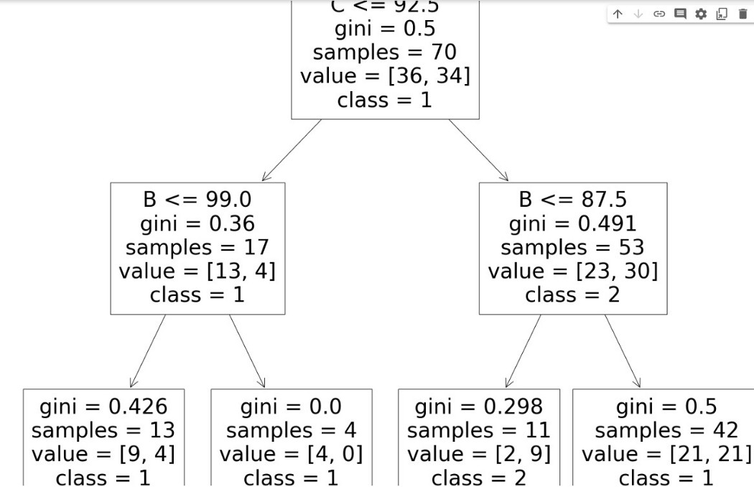

Depiction of Sample Rules Generated

